
Datasheet
No.: 02RQBB2456P-DC 24-B15-15°
Version: 2025-10-30-02
ITEM: 02RQBB2456P | INPUT VOLTAGE(V)  DC 24 | LENS  B15 | LENS DEGREE(°)θ1/2  15° |  | CCT  3000K
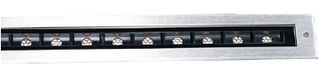  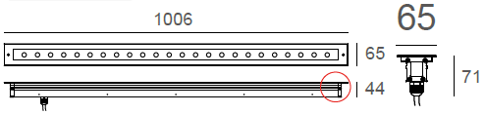 |  | LIGHT SOURCE |  | 24×1.2W
 |  | CONSUMPTION(W) |  | 38.4
 |  | OPERATING CURRENT(MA) |  | 1600
 |  | POWER FACTOR(PF) |  | 1
 |  | LUMINANCE(LM) |  | 2968
 |  | COLOR RENDERING INDEX |  | RA: 80
 |  | IK RATING |  | 09
 |  | IP RATING |  | 67
PRODUCT SPECIFICATIONS
HOUSING | Extruded aluminum, powder coated
FRONT COVER | SUS 316L#, Hard chrome-plated
LIGHT WINDOW | Tempered step glass.T=6mm
GLASS PRESSURE CAPACITY | 2,524 kgs.
CABLE GLAND | IP68 PG-9 PA66
GASKET | Glass and Housing are silicone seaLED Type
SLEEVE | RAL9005 Powder Coated Aluminum
LENS | Optical Lens.efficiency≥85%
LED TYPE | SMD
POWER CABLE | Outside of luminaire (Without waterstopper)  12V/24V: H05RN-F 2×1.0mm², L=0.5m
OPERATING TEMPERATURE | -20˚C~40˚C
DIMMING SUPPORT | External DALl supported TRIAC,0-10V,PWM via external driver on request
WATER PROOF SOLUTION
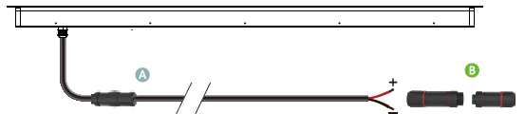
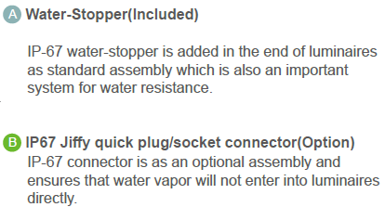

SLEEVE(INCLUDED)
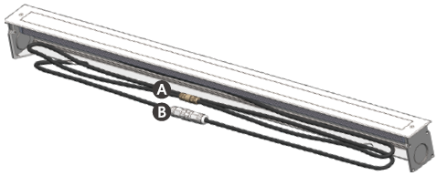
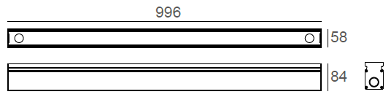
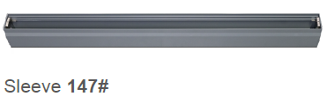

PHOTOMETRIC
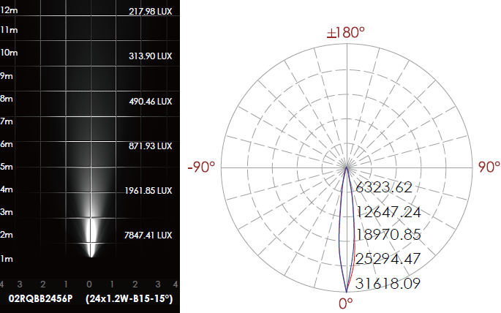

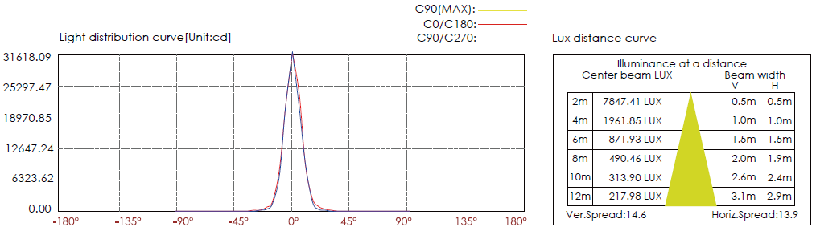

CERTIFICATES


