
Datasheet
No.: 02RQBB0656P-120 240-B15-15°
Version: 2025-10-30-02
ITEM: 02RQBB0656P | INPUT VOLTAGE(V)  120 240 | LENS  B15 |  | LENS DEGREE(°)θ1/2  15° |  | CCT  3000K
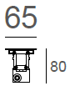  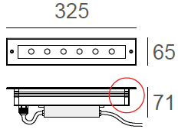  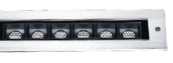 |  |  | LIGHT SOURCE |  | 6×1.2W
 |  |  | CONSUMPTION(W) |  | 120=8.5 240=8.7
 |  |  | OPERATING CURRENT(MA) |  | 120=71 240=41
 |  |  | POWER FACTOR(PF) |  | 1
 |  |  | LUMINANCE(LM) |  | 770
 |  |  | COLOR RENDERING INDEX |  | RA: 80
 |  |  | IK RATING |  | 09
 |  |  | IP RATING |  | 67
PRODUCT SPECIFICATIONS
HOUSING | Extruded aluminum, powder coated
FRONT COVER | SUS 316L#, Hard chrome-plated
LIGHT WINDOW | Tempered step glass.T=6mm
GLASS PRESSURE CAPACITY | 2,524 kgs.
CABLE GLAND | IP68 PG-9 PA66
GASKET | Glass and Housing are silicone seaLED Type
SLEEVE | RAL9005 Powder Coated Aluminum
LENS | Optical Lens.efficiency≥85%
LED TYPE | SMD
POWER CABLE | Outside of luminaire (Without waterstopper)  120V/240V: H05RN-F 3×1.0mm², L=0.5m
OPERATING TEMPERATURE | -20˚C~40˚C
DIMMING SUPPORT | External DALl supported TRIAC,0-10V,PWM via external driver on request
WATER PROOF SOLUTION
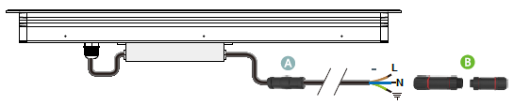
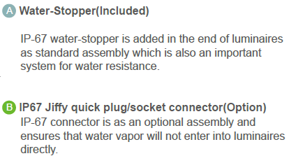

SLEEVE(INCLUDED)
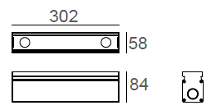
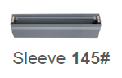
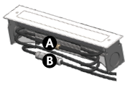

PHOTOMETRIC
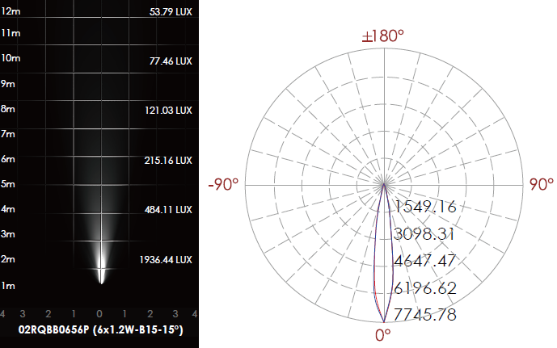

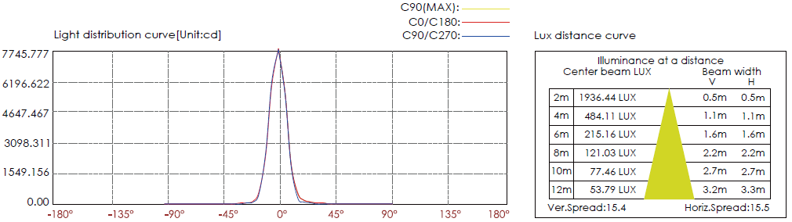

CERTIFICATES


