
Datasheet
No.: 02CFRB0125-DC 24-B71-24°
Version: 2025-10-30-03
ITEM: 02CFRB0125 | INPUT VOLTAGE(V)  DC 24 |  | LENS  B71 | LENS DEGREE(°)θ1/2  24° |  | CCT  3000K
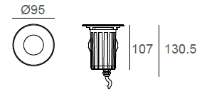  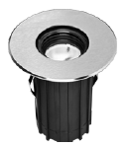 |  |  | LIGHT SOURCE |  | 1×5W
 |  |  | CONSUMPTION(W) |  | 6.3
 |  |  | OPERATING CURRENT(MA) |  | 265
 |  |  | POWER FACTOR(PF) |  | 1
 |  |  | LUMINANCE(LM) |  | 460
 |  |  | COLOR RENDERING INDEX |  | RA: 80
 |  |  | IK RATING |  | 08
 |  |  | IP RATING |  | 67
PRODUCT SPECIFICATIONS
HOUSING | 12# Die-casting aluminum powder coated.  T=60-80μm Adhesion of ISO class 1/ATM class 4B
FRONT COVER | SUS 316L#, Hard chrome-plated
LIGHT WINDOW | Tempered step glass.T=6mm
GLASS PRESSURE CAPACITY | 02CFRB0125: 1,195kgs
CABLE GLAND | IP68 PG-9 PA66
OPERATING TEMPERATURE | -20˚C~40˚C
GASKET | Silicon rubber molding shaped seal
SLEEVE MATERIAL | PC/ABS ALLOYS
REFLECTOR | Optical Reflector efficiency≥90%
LED TYPE | COB
LED DRIVER | Built in on/off driver
POWER CABLE | Outside of luminaire (Without waterstopper)  H05RN-F 2X1.0mm² L=0.5m(low voltage)
ACCESSORIES(Optional)
SLEEVE  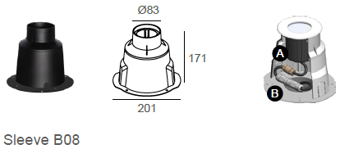  Option1 |  | 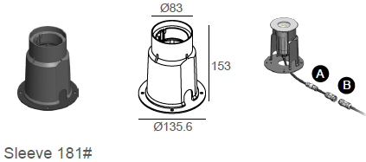  Option2
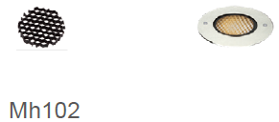  Honeycomb Louver |  | 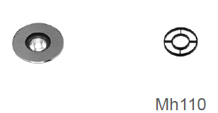  Anti Glare Louver

WATER PROOF SOLUTION
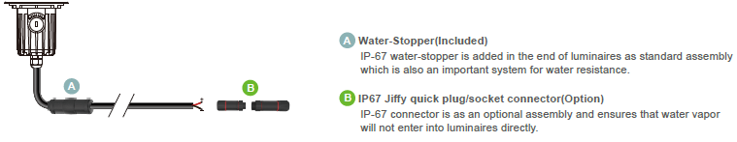

PHOTOMETRIC
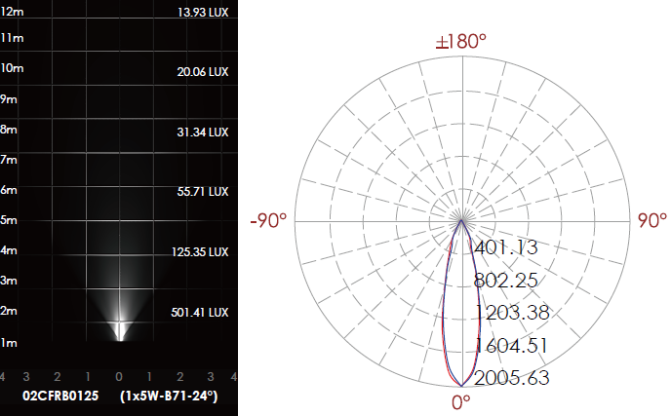

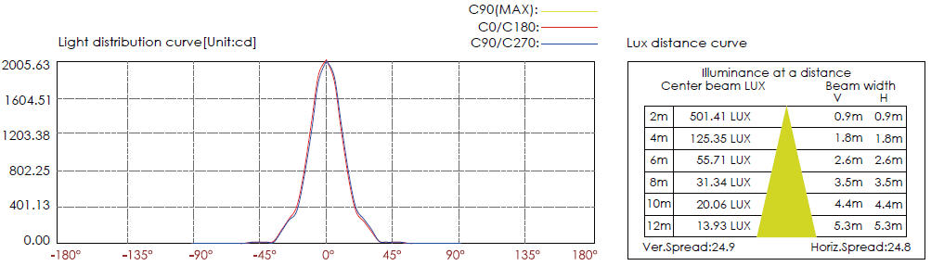

CERTIFICATES




