
Datasheet
No.: 01CND1434-240
Version: 2025-10-29-03
ITEM: 01CND1434 | INPUT VOLTAGE(V)  240 |  | LENS  N/A | LENS DEGREE(°)θ1/2  N/A |  | CCT  3000K
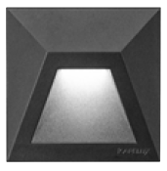  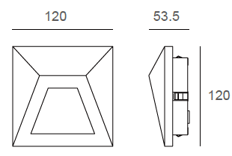 |  |  | LIGHT SOURCE |  | 14×0.5W
 |  |  | CONSUMPTION(W) |  | 7.5
 |  |  | OPERATING CURRENT(MA) |  | 32
 |  |  | POWER FACTOR(PF) |  | 1
 |  |  | LUMINANCE(LM) |  | 112
 |  |  | COLOR RENDERING INDEX |  | RA: 80
 |  |  | IK RATING |  | 10
 |  |  | IP RATING |  | 65
PRODUCT SPECIFICATIONS
HOUSING | 12# Die-casting aluminum KAP7037 finishing or powder Painting  T=60-80μm.Adhesion of ISO class 1/ASTM class 4B
FRONT COVER | 12# Die-casting aluminum powder coated  T=60-80μm.Adhesion of ISO class 1/ASTM class 4B
LIGHT WINDOW | Glass
CABLE GLAND | IP67 copper and nicked coated
GASKET | Tooling shaped seal
SLEEVE | Option 1: PC/ABS ALLOYS with iron bracket  Option 2: Stainless Steel
OPERATING RESTRICT | -20˚C~40˚C
LED TYPE | SMD
LED DRIVER | Built in on/off driver
POWER CABLE | Outside of luminaire (Without waterstopper)  AC power: H05RN-F 3×1.0mm², L=0.3m(120V/240V)
DIMMING SUPPORT | External DALl supported TRIAC,0-10V,PWM via external driver on request
RECESSED SLEEVE(Included) |  | DIAGRAM OF INSTRUCTION
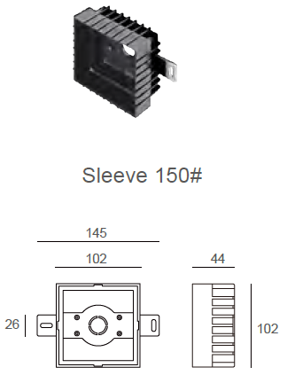 |  | 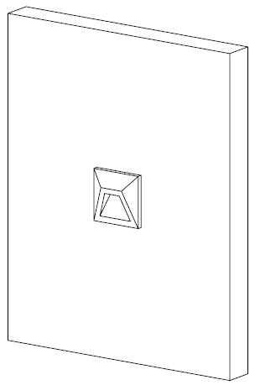  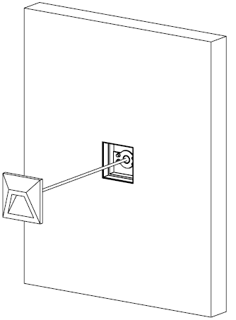

PAINTING COLOR
Primary     | Secondary            

PHOTOMETRIC
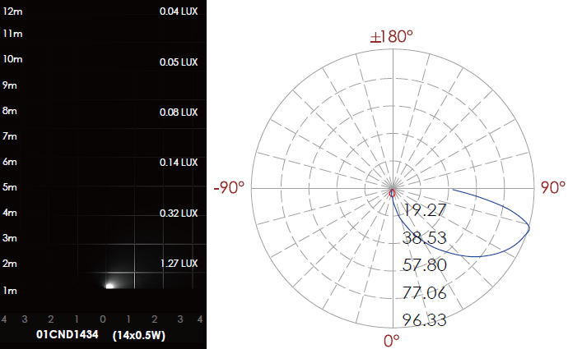

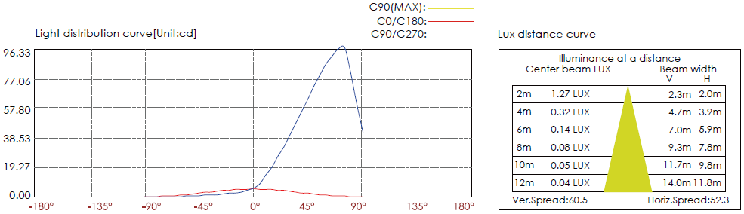

CERTIFICATES


