
Datasheet
No.: 01BCD4232-DC 24
Version: 2025-10-29-03
ITEM: 01BCD4232 | INPUT VOLTAGE(V)  DC 24 |  | LENS  N/A | LENS DEGREE(°)θ1/2  N/A |  | CCT  3000K
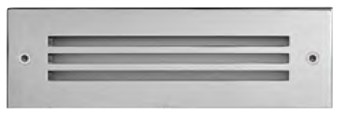  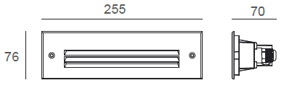 |  |  | LIGHT SOURCE |  | 42×0.07W
 |  |  | CONSUMPTION(W) |  | 5.3
 |  |  | OPERATING CURRENT(MA) |  | 200
 |  |  | POWER FACTOR(PF) |  | 1
 |  |  | LUMINANCE(LM) |  | CW=47 WW=44
 |  |  | COLOR RENDERING INDEX |  | RA: 80
 |  |  | IK RATING |  | 10
 |  |  | IP RATING |  | 65
PRODUCT SPECIFICATIONS
FRONT COVER | Stainless Steel 316L#
HOUSING | 12# Die-casting aluminum powder coated  T=60-80μm. Adhesion of ISO class 1/ASTM class 4B
LIGHT WINDOW | UVstop & Fireproof PC Glass T=3mm
CABLE GLAND | IP68 PG-9 PA66
GASKET | Molding Shaped silicone seal
SLEEVE | SUS 202#
OPERATING RESTRICT | -20˚C~40˚C
LED DRIVER | Built in on/off driver
POWER CABLE | Outside of luminaire (Without waterstopper)  DC power: H05RN-F 2×1.0mm², L=0.5m(12V/24V)
LED TYPE | SMD
DIMMING SUPPORT | External DALl supported TRIAC,0-10V,PWM via external driver on request
RECESSED SLEEVE(Included) |  | DIAGRAM OF INSTRUCTION
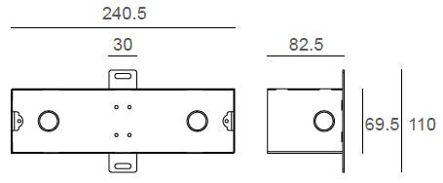  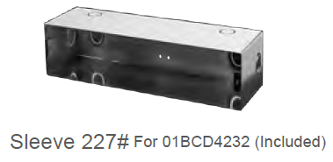 |  | 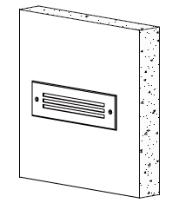  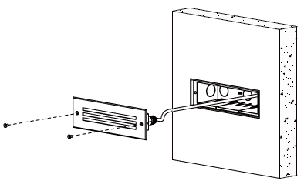

PAINTING COLOR
Primary     | Secondary            

PHOTOMETRIC
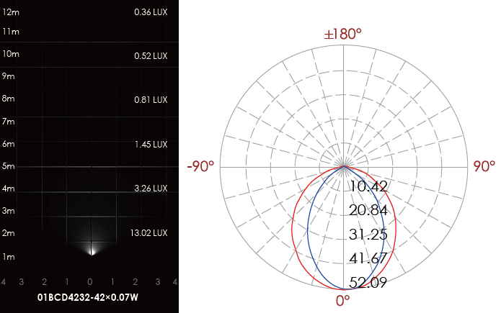

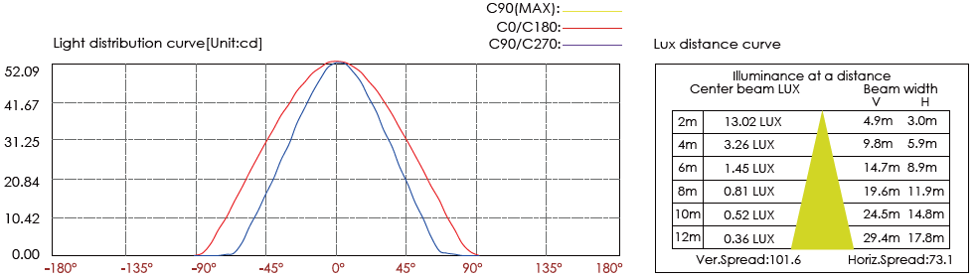

CERTIFICATES


