
Datasheet
No.: 09ARHD8434A-120 240
Version: 2025-11-06-02
ITEM: 09ARHD8434A | INPUT VOLTAGE(V)  120 240 | LENS  N/A | LENS DEGREE(°)θ1/2  N/A |  | CCT  3000K
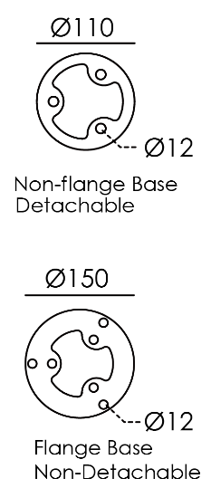  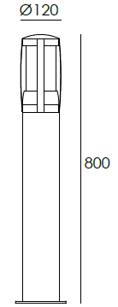  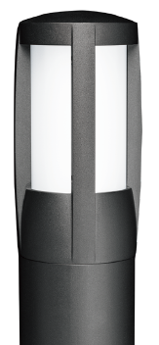 |  | HEIGHT(mm) |  | 800
 |  | LIGHT SOURCE |  | 84×0.1W
 |  | CONSUMPTION(W) |  | 120=9.4 240=9.6
 |  | OPERATING CURRENT(MA) |  | 120=79 240=43
 |  | POWER FACTOR(PF) |  | 0.917
 |  | LUMINANCE(LM) |  | 497
 |  | COLOR RENDERING INDEX |  | RA: 80
 |  | IK RATING |  | 05
 |  | IP RATING |  | 65
PRODUCT SPECIFICATIONS
HOUSING | 12# Die-casting aluminum powder coated.  T=60-80μm Adhesion of ISO class 1/ASTM class 4B
LIGHT WINDOW | PMMA
LED TYPE | SMD
LED DRIVER | Built in on/off driver
OPERATING TEMPERATURE | -20˚C~40˚C
POWER CABLE | Outside of luminaire (Without waterstopper)  120V/240V: H05RN-F 3×1.0mm², L=0.5m
BASE | Flange base
DIMMING SUPPORT | External DALl supported TRIAC,0-10V,PWM via external driver on request

BASE OPTIONS
Base Style | 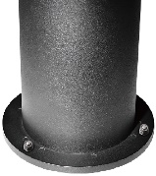   |   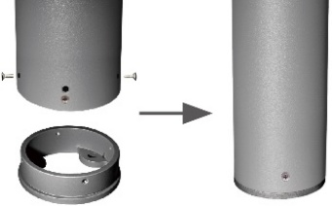
Inground Base  (Optional) | 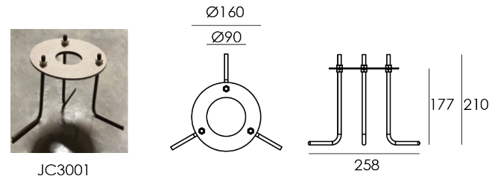 | 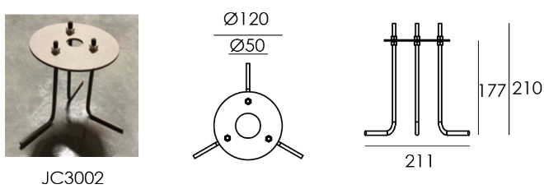
Ground Anchor  Base And  Installationb steps  (Optional) | 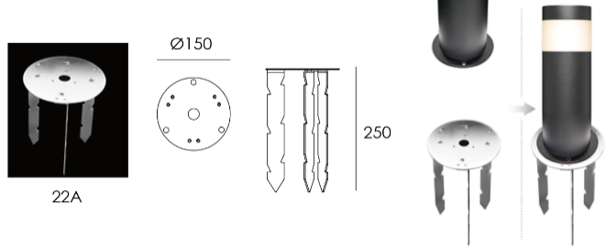 | 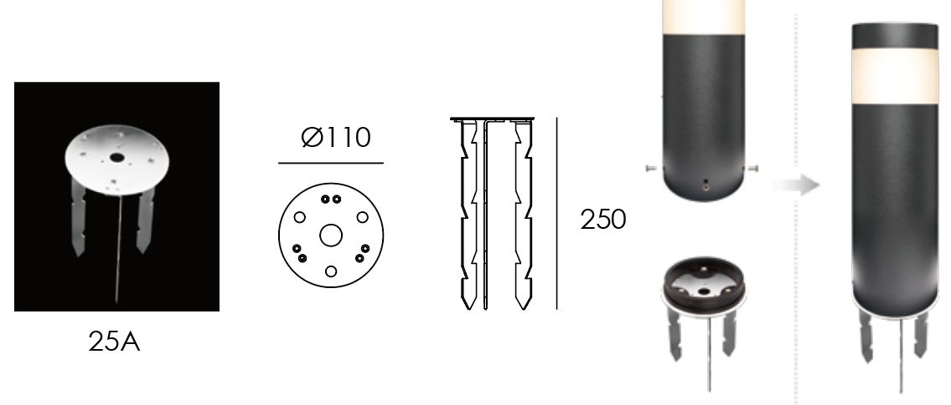

PAINTING COLOR







PHOTOMETRIC
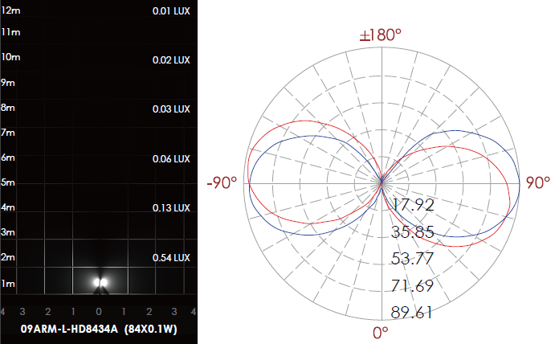

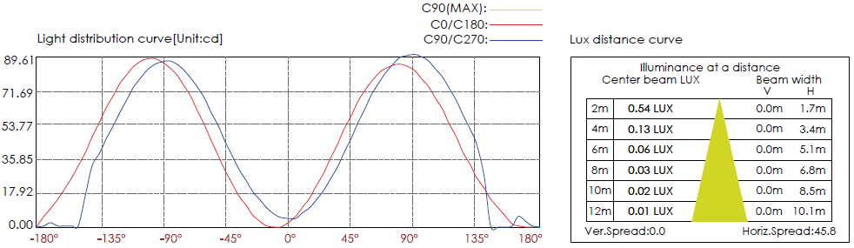

CERTIFICATES


