
Datasheet
No.: 08ZKB0170-DC 24-B113-36°
Version: 2025-11-06-02
ITEM: 08ZKB0170 | INPUT VOLTAGE(V)  DC 24 |  | LENS  B113 | LENS DEGREE(°)θ1/2  36° |  | CCT  3000K
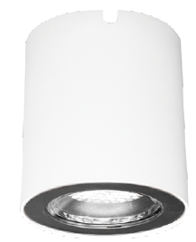  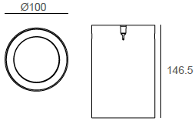  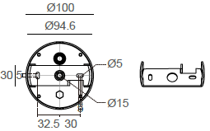 |  |  | LIGHT SOURCE |  | 1×18W
 |  |  | CONSUMPTION(W) |  | 20
 |  |  | OPERATING CURRENT(MA) |  | 833
 |  |  | POWER FACTOR(PF) |  | 1
 |  |  | LUMINANCE(LM) |  | 2000
 |  |  | COLOR RENDERING INDEX |  | RA: 80
 |  |  | IK RATING |  | 08
 |  |  | IP RATING |  | 65
PRODUCT SPECIFICATIONS
HOUSING | 12# Dietasting aluminum powder painting
PAINTING | Powder coating, T= 60~80 μm.  Adhesion of ISO class 1/ASTM class 4B
LENS | OPTICS reflector. efficiency≥85%
LED TYPE | COB
POWER CABLE | Outside of luminaire (Without waterstopper)  H05RN-F 2×1.0mm², L=0.3m(12V/24V)
OPERATING TEMPERATURE | -20˚ C~40˚ C
HONEYCOMB LOUVER |  | SAFETY HANGER
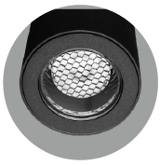  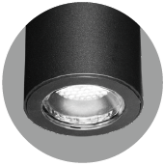 |  | Instructions for the use of safety hanger  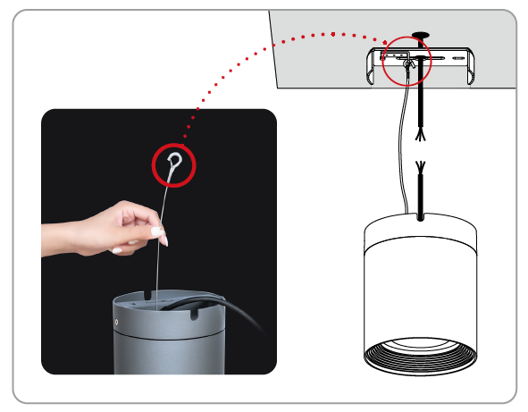  When wiring, install the safety hanger on the ceiling mount. There is no need to remove the hanger after completion, which can be used as a protection when removing the fitting.

PAINTING COLOR
  Primary   | Secondary            

PHOTOMETRIC
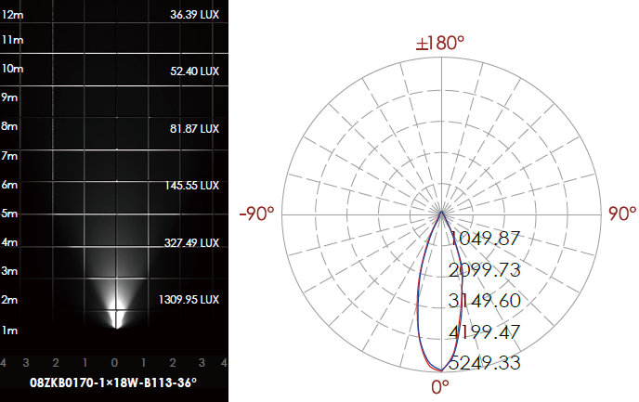

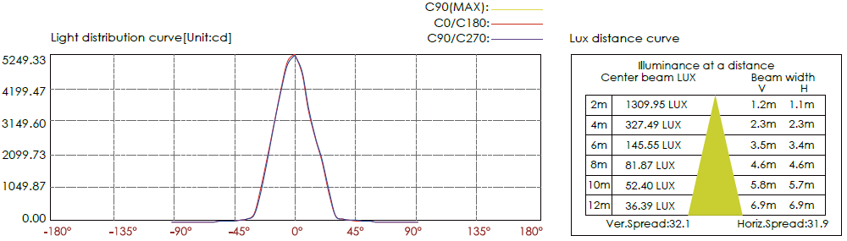

CERTIFICATES


