
Datasheet
No.: 08EKB0174-120 240-B57-60°
Version: 2025-11-06-02
ITEM: 08EKB0174 | INPUT VOLTAGE(V)  120 240 | LENS  B57 | LENS DEGREE(°)θ1/2  60° |  | CCT  3000K
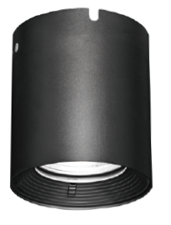  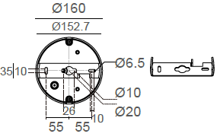  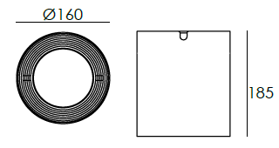 |  | LIGHT SOURCE |  | 1×30W
 |  | CONSUMPTION(W) |  | 120=34.5 240=34.2
 |  | OPERATING CURRENT(MA) |  | 120=286 240=151
 |  | POWER FACTOR(PF) |  | 0.921
 |  | LUMINANCE(LM) |  | 2851
 |  | COLOR RENDERING INDEX |  | RA: 80
 |  | IK RATING |  | 06
 |  | IP RATING |  | 65
PRODUCT SPECIFICATIONS
HOUSING | 12# Die-casting aluminum powder painting
PAINTING | Powder coating, T= 60~80 μm.  Adhesion of ISO class 1/ASTM class 4B
LENS | OPTICS Reflector. efficiency≥85%
LED TYPE | COB
POWER CABLE | Outside of luminaire (Without waterstopper)  H05RN-F 3×1.0mm², L=0.3m(120V/240V)
OPERATING RESTRIC | -20˚ C~40˚ C
ACCESSORIES(Optional) | SAFETY HANGER
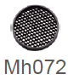  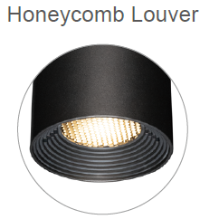 | Instructions for the use of safety hanger  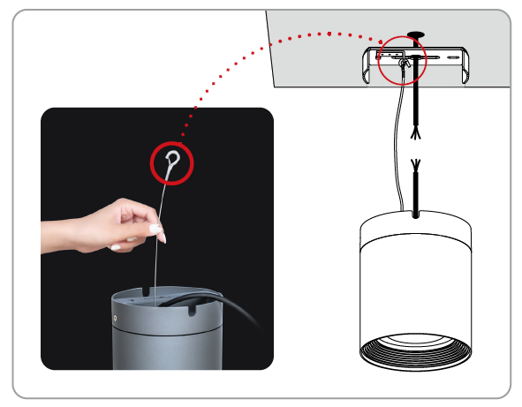  When wiring, install the safety hanger on the ceiling mount. There is no need to remove the hanger after completion, which can be used as a protection when removing the fitting.

PAINTING COLOR
  Primary   | Secondary            

PHOTOMETRIC
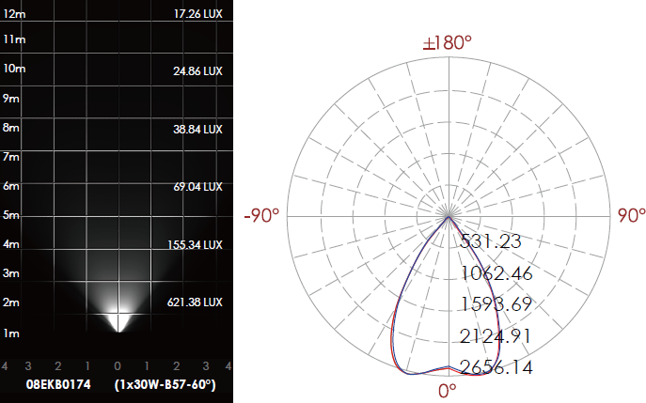

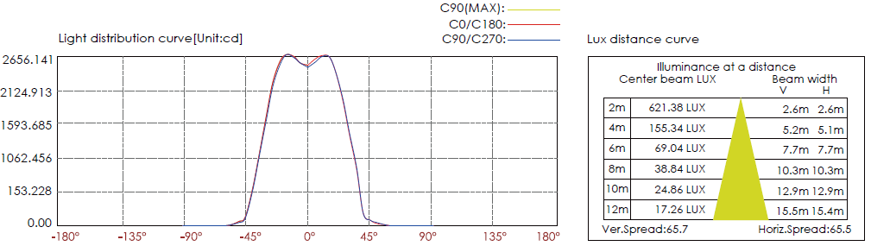

CERTIFICATES



