
Datasheet
No.: 2ED7FBE4856 (TWO SIDE)-DC 24-92°×88°
Version: 2025-10-13-02
ITEM: 07FBE2ED4856(TWO SIDE) | INPUT VOLTAGE(V)  DC 24 | LENS  N/A | LENS DEGREE(°)θ1/2  92°×88° |  | CCT  3000K
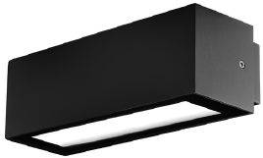  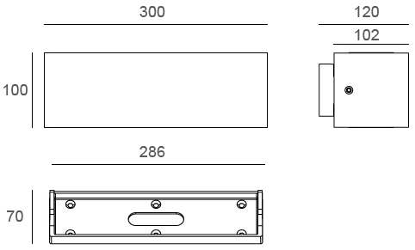 |  | LIGHT SOURCE |  | 48×1W
 |  | CONSUMPTION(W) |  | 55
 |  | OPERATING CURRENT(MA) |  | 2292
 |  | POWER FACTOR(PF) |  | 1
 |  | LUMINANCE(LM) |  | 2100×2
 |  | COLOR RENDERING INDEX |  | RA: 80
 |  | IK RATING |  | 06
 |  | IP RATING |  | 65
PRODUCT SPECIFICATIONS
HOUSING | 12# Die-casting aluminum finishing or powder painting  T=60-80µm.Adhesion of ISO class 1/ASTM class 4B
LIGHT WINDOW | Temperetd forsted glass T=3mm
LED TYPE | SMD
GASKET | Tooling shaped seal
DRIVER | Built in on/off driver
OPERATING TEMPERATURE | -20°C-40°C
POWER CABLE | Outside of luminaire (Without waterstopper)  12V/24V: H05RN-F 2×1.0mm², L=0.3m
DIMMING SUPPORT | External DALl supported TRIAC,0-10V,PWM via external driver on request
DIAGRAM OF INSTRUCTION
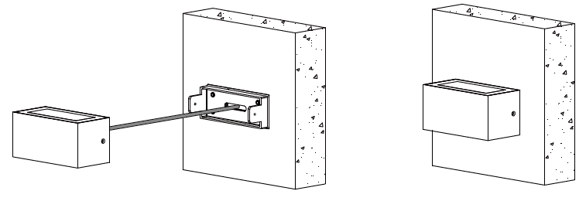
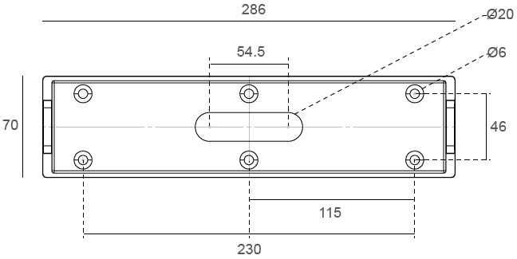

PAINTING COLOR
Primary   |   Secondary            

PHOTOMETRIC
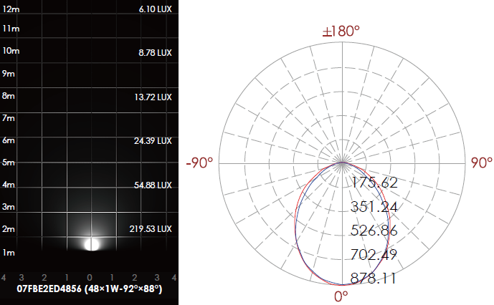

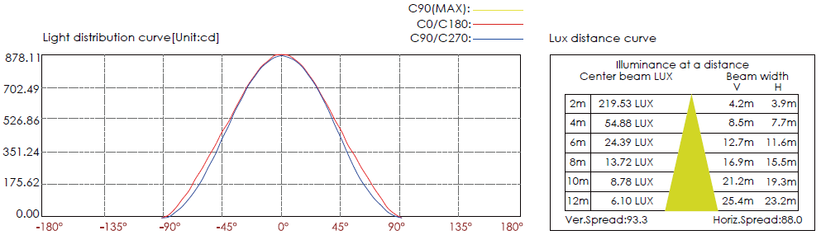

CERTIFICATES




