
Datasheet
No.: 07KTD3032-DC 24
Version: 2025-11-06-03
ITEM: 07KTD3032 | INPUT VOLTAGE(V)  DC 24 | LENS  N/A |  | LENS DEGREE(°)θ1/2  N/A |  | CCT  3000K
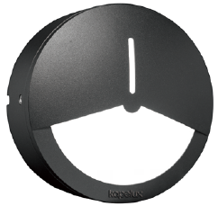  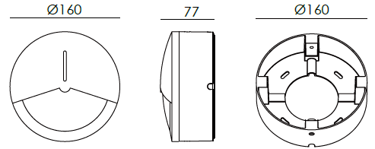 |  |  | LIGHT SOURCE |  | 30×0.07W
 |  |  | CONSUMPTION(W) |  | 3.2
 |  |  | OPERATING CURRENT(MA) |  | 135
 |  |  | POWER FACTOR(PF) |  | 1
 |  |  | LUMINANCE(LM) |  | 87
 |  |  | COLOR RENDERING INDEX |  | RA: 80
 |  |  | IK RATING |  | 09
 |  |  | IP RATING |  | 65
PRODUCT SPECIFICATIONS
HOUSING&MOUNTING BASE | 12# Die-casting aluminum finishing or powder coated painting  T=60-80µm.Adhesion of ISO class 1/ASTM class 4B
LIGHT WINDOW | UVstop & Fireproof PC T=2.5mm
GASKET | Tooling shaped seal
SLEEVE | ADC
LED TYPE | SMD
LED DRIVER | Built in on/off driver
OPERATING TEMPERATURE | -20˚ C~40˚ C
POWER CABLE | Outside of luminaire (Without waterstopper)  12V/24V: H05RN-F 2×1.0mm², L=0.3m
DIAGRAM OF INSTRUCTION
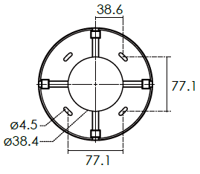
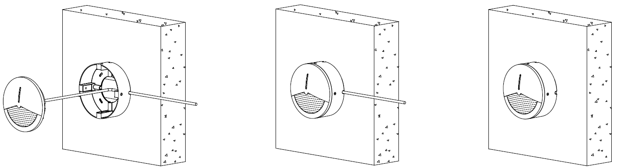

PAINTING COLOR
  Primary   | Secondary            

PHOTOMETRIC
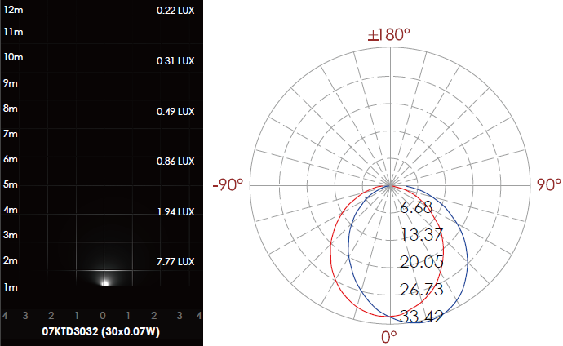

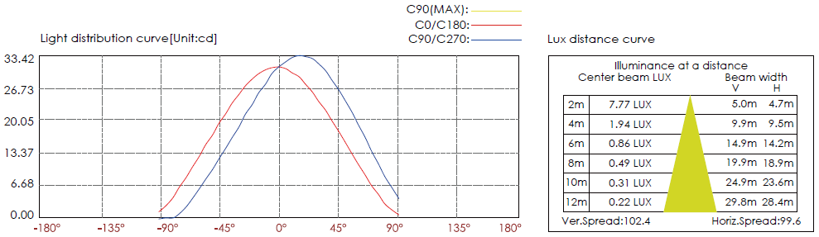

CERTIFICATES




