
Datasheet
No.: 07HWD1433(ONE SIDE)-240-87°×60°
Version: 2025-11-05-03
ITEM: 07HWD1433 (ONE SIDE) | INPUT VOLTAGE(V)  240 | LENS  N/A |  | LENS DEGREE(°)θ1/2  87°×60° |  | CCT  3000K
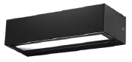  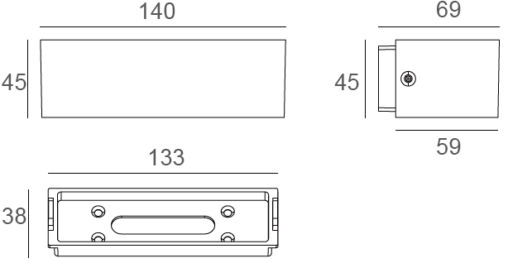 |  |  | LIGHT SOURCE |  | 14×0.2W
 |  |  | CONSUMPTION(W) |  | 3.75
 |  |  | OPERATING CURRENT(MA) |  | 15
 |  |  | POWER FACTOR(PF) |  | 0.965
 |  |  | LUMINANCE(LM) |  | 150
 |  |  | COLOR RENDERING INDEX |  | RA: 80
 |  |  | IK RATING |  | 06
 |  |  | IP RATING |  | 65
PRODUCT SPECIFICATIONS
HOUSING | 12# Die-casting aluminum finishing or powder painting T=60-80µm.  Adhesion of ISO class 1/ASTM class 4B
GLASS | Temperetd forsted glass T=3mm
LED TYPE | SMD
GASKET | Tooling shaped seal
LED DRIVER | Built in on/off driver
OPERATING TEMPERATURE | -30°C-40°C
POWER CABLE | Outside of luminaire (Without waterstopper)  120V/240V: H05RN-F 3×1.0mm², L=0.3m
DIAGRAM OF INSTRUCTION
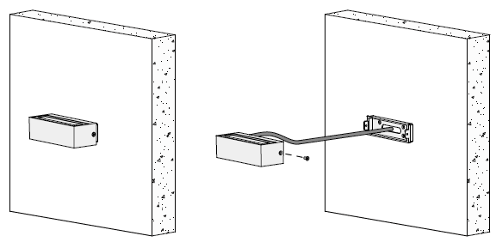
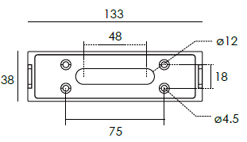

PAINTING COLOR
Primary   |   Secondary            

PHOTOMETRIC
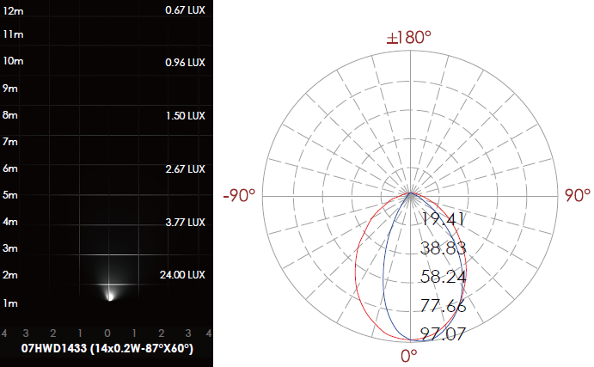

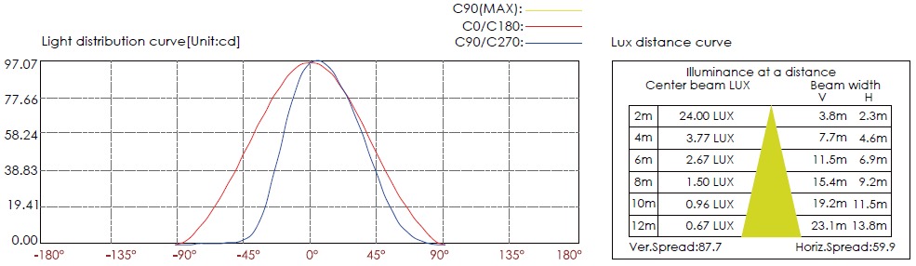

CERTIFICATES




