
Datasheet
No.: 07GRB1256(TWO SIDE)-DC 24-40°
Version: 2025-11-05-03
ITEM: 07GRB1256(TWO SIDE) | INPUT VOLTAGE(V)  DC 24 | LENS  N/A | LENS DEGREE(°)θ1/2  40° |  | CCT  3000K
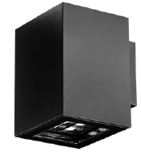  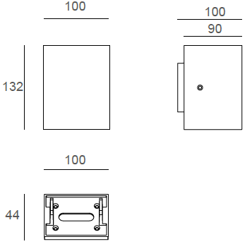 |  | LIGHT SOURCE |  | 12×1W
 |  | CONSUMPTION(W) |  | 13
 |  | OPERATING CURRENT(MA) |  | 540
 |  | POWER FACTOR(PF) |  | 1
 |  | LUMINANCE(LM) |  | 600×2
 |  | COLOR RENDERING INDEX |  | RA: 80
 |  | IK RATING |  | 08
 |  | IP RATING |  | 65
PRODUCT SPECIFICATIONS
HOUSING | 12# Die-casting aluminum powder Painting  T=60-80μm.Adhesion of ISO class 1/ASTM class 4B
GLASS | UVstop & Fireproof PC T=3mm
GASKET | Tooling shaped seal
LED TYPE | SMD
LED DRIVER | Built in on/off driver
POWER CABLE | Outside of luminaire (Without waterstopper)  12V/24V: H05RN-F 2×1.0mm², L=0.3m
DIMMING SUPPORT | External DALl supported TRIAC,0-10V,PWM via external driver on request
OPERATING RESTRICT | -20˚C~40˚C
DIAGRAM OF INSTRUCTION
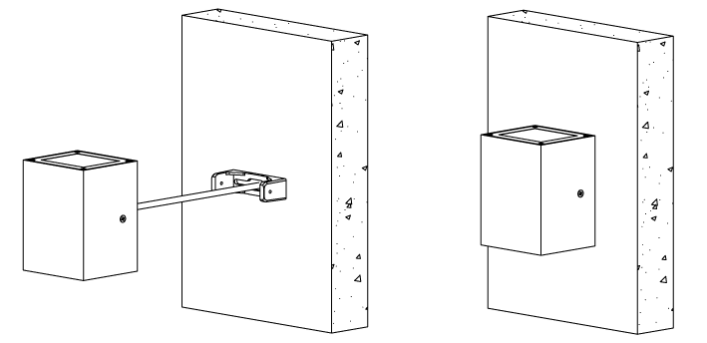
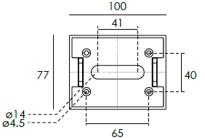

PAINTING COLOR
Primary   |   Secondary            

PHOTOMETRIC
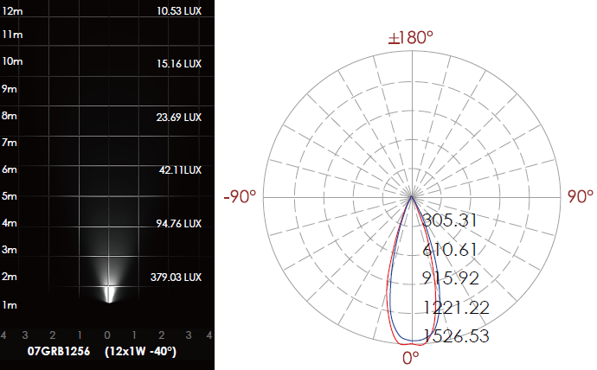

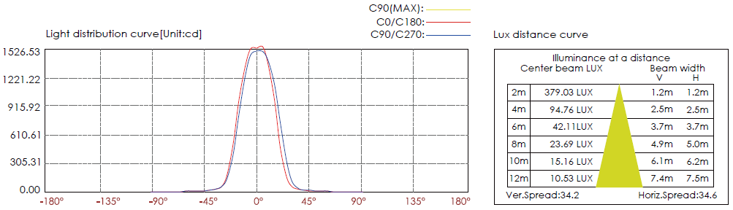

CERTIFICATES




