
Datasheet
No.: 07FMHB0958-120 240-FB12B5-30°
Version: 2025-11-06-03
ITEM: 07FMHB0958 | INPUT VOLTAGE(V)  120 240 | LENS  FB12B5 | LENS DEGREE(°)θ1/2  30° |  | CCT  3000K
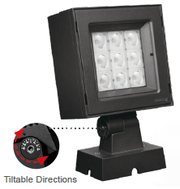  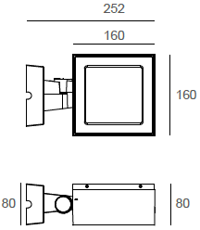 |  | LIGHT SOURCE |  | 9×3W
 |  | CONSUMPTION(W) |  | 120=29.6 240=30
 |  | OPERATING CURRENT(MA) |  | 120=245 240=133
 |  | POWER FACTOR(PF) |  | 1
 |  | LUMINANCE(LM) |  | 2632
 |  | COLOR RENDERING INDEX |  | RA: 80
 |  | IK RATING |  | 06
 |  | IP RATING |  | 65
PRODUCT SPECIFICATIONS
HOUSING | 12# Die-casting aluminum finishing or powder Painting  T=60-80μm. Adhesion of ISO class 1/ASTM class 4B
LIGHT WINDOW | Tempered Glass 3mm
GASKET | Tooling shaped seal
LED | SMD
LED DRIVER | Built in on/off driver
OPERATING TEMPERATURE | -20˚ C~40˚ C
POWER CABLE | Outside of luminaire (Without waterstopper)  120V/240V: H05RN-F 3×1.0mm², L=0.3m
DIAGRAM OF INSTRUCTION
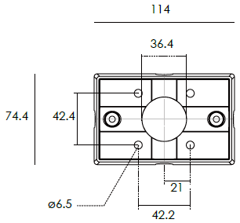
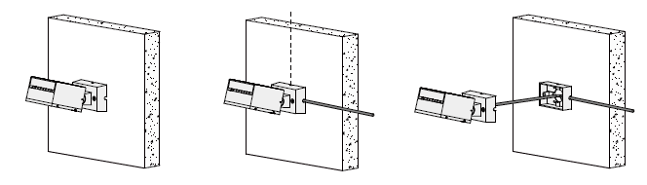

DIAGRAM OF INSTRUCTION
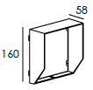  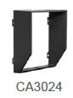  BEVEL CUT HOOD | 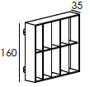  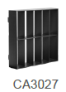  ANTI GLARE LOUVER

PAINTING COLOR
  Primary   | Secondary            

PHOTOMETRIC
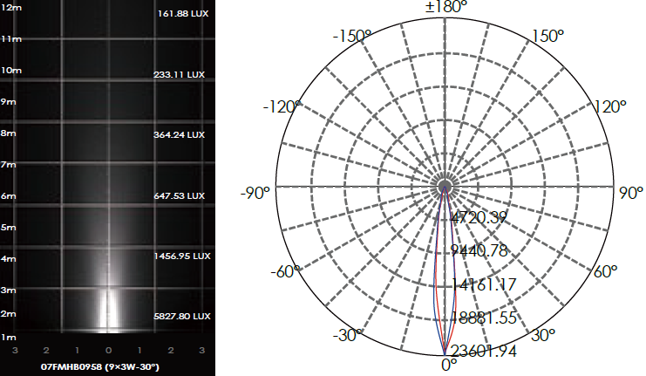

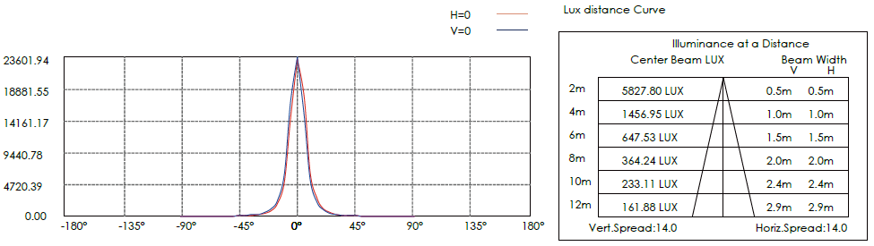

CERTIFICATES




