
Datasheet
No.: 07AHR0128K(ONE SIDE)-120 240-R8-24°
Version: 2025-11-05-03
ITEM: 07AHR0128K(ONE SIDE) | INPUT VOLTAGE(V)  120 240 | REFLECTOR  R8 | LENS DEGREE(°)θ1/2  24° |  | CCT  3000K
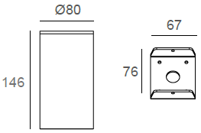  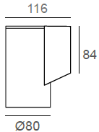  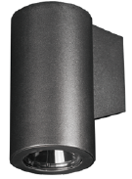 |  | LIGHT SOURCE |  | 1×10W
 |  | CONSUMPTION(W) |  | 120=13.1 240=13.5
 |  | OPERATING CURRENT(MA) |  | 120=112 240=63
 |  | POWER FACTOR(PF) |  | 0.947
 |  | LUMINANCE(LM) |  | CW=1335 WW=1170
 |  | COLOR RENDERING INDEX |  | RA: 80
 |  | IK RATING |  | 10
 |  | IP RATING |  | 65
PRODUCT SPECIFICATIONS
HOUSING | 12# Die-Casting aluminum alloy #6063 powder coated  T=60-80μm. Adhesion of ISO class 1/ASTM class 4B
LIGHT WINDOW | PC
GASKET | Tooling shaped seal
OPERATING RESTRICT | -20˚ C~40˚ C
LED DRIVER | Built in on/off driver
LED TYPE | COB
POWER CABLE | Outside of luminaire (Without waterstopper)  120V/240V: H05RN-F 3×1.0mm², L=0.3m
DIAGRAM OF INSTRUCTION
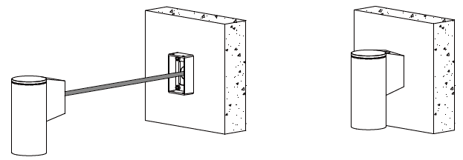
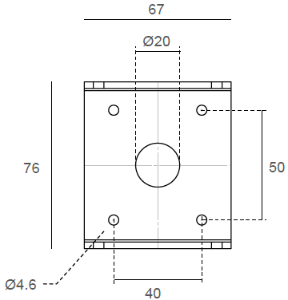

PAINTING COLOR
Primary   |   Secondary            

PHOTOMETRIC
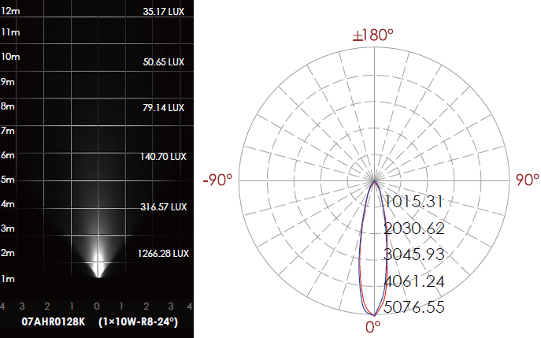

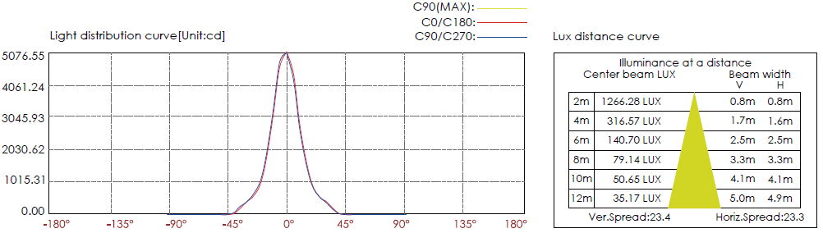

CERTIFICATES




