
Datasheet
No.: 07BDD0125-240-360°
Version: 2025-11-06-03
ITEM: 07BDD0125 | INPUT VOLTAGE(V)  240 | LENS  N/A | LENS DEGREE(°)θ1/2  360° |  | CCT  3000K
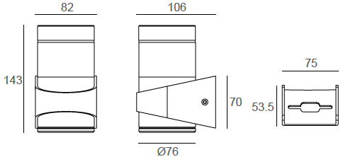  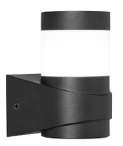 |  | LIGHT SOURCE |  | 1×4.5W
 |  | CONSUMPTION(W) |  | 6
 |  | OPERATING CURRENT(MA) |  | 29
 |  | POWER FACTOR(PF) |  | 1
 |  | LUMINANCE(LM) |  | 409
 |  | COLOR RENDERING INDEX |  | RA: 80
 |  | IK RATING |  | 08
 |  | IP RATING |  | 65
PRODUCT SPECIFICATIONS
HOUSING | 12# Die-casting aluminum finishing or powder painting T=60-80μm.  Adhesion of ISO class 1/ASTM class 4B
LIGHT WINDOW | PMMA
LED DRIVER | Built in on/off driver
LED TYPE | COB
OPERATING TEMPERATURE | -20˚ C-40˚ C
POWER CABLE | Outside of luminaire (Without waterstopper)  120V/240V: H05RN-F 3×1.0mm², L=0.3m
DIAGRAM OF INSTRUCTION
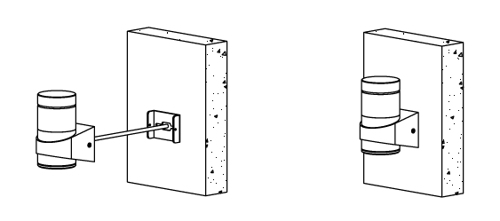
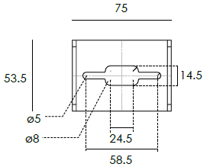

PAINTING COLOR
Primary   |   Secondary            

PHOTOMETRIC
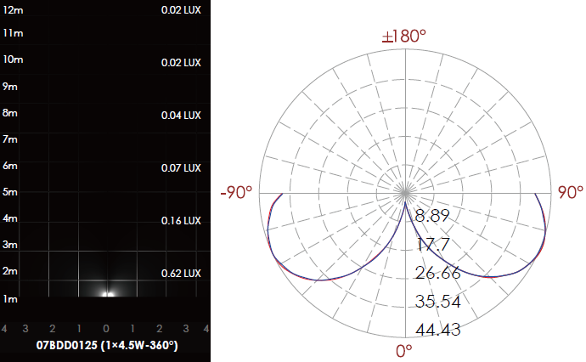

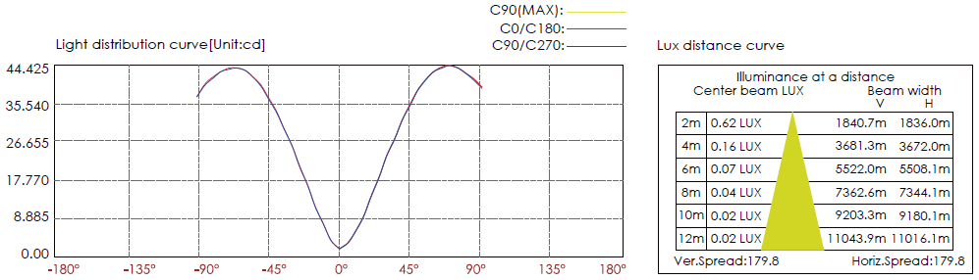

CERTIFICATES




