
Datasheet
No.: 07ACXB0258-DC 24-B33-30°
Version: 2025-11-06-03
ITEM: 07ACXB0258 | INPUT VOLTAGE(V)  DC 24 |  | LENS  B33 |  | LENS DEGREE(°)θ1/2  30° |  | CCT  3000K
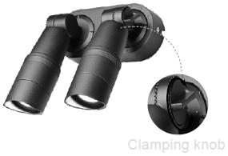  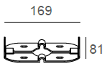  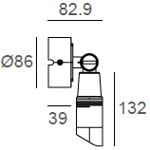  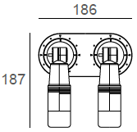 |  |  |  | LIGHT SOURCE |  | 2×3W
 |  |  |  | CONSUMPTION(W) |  | 9
 |  |  |  | OPERATING CURRENT(MA) |  | 374
 |  |  |  | POWER FACTOR(PF) |  | 1
 |  |  |  | LUMINANCE(LM) |  | 288x2
 |  |  |  | COLOR RENDERING INDEX |  | RA: 80
 |  |  |  | IK RATING |  | 04
 |  |  |  | IP RATING |  | 65
PRODUCT SPECIFICATIONS
FRONT COVER& HOUSING | 12# Die-casting aluminum finishing or powder Painting  T=60-80µm.Adhesion of ISO class 1/ASTM class 4B
LENS | OPTICS Lens, efficiency≥85%
LED TYPE | COB
LIGHT WINDOW | Tempered glass. T=3mm
CABLE GLAND | Nickel coated copper
GASKET | Tooling shaped seal
PCB | Excellent heat conductivity aluminum, coefficient of heat Conductivity≥2.0w/mk
LED DRIVER | Built in on/off driver
POWER CABLE | Outside of luminaire (Without waterstopper)  12V/24V: H05RN-F 2×1.0mm², L=0.4m
DIMMING SUPPORT | External DALl supported TRIAC,0-10V, PWM via external driver on request
OPERATING RESTRICT | -20°C~40°C
PAINTING COLOR
Primary     |  |   Secondary          

INSTALLATION TYPES BY DIFFERENT WIRING
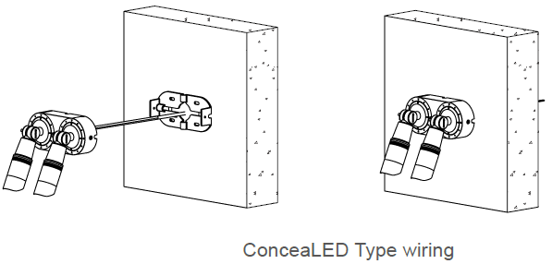
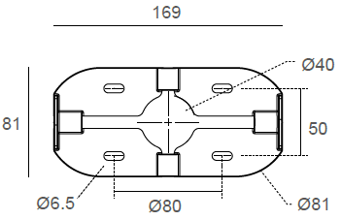
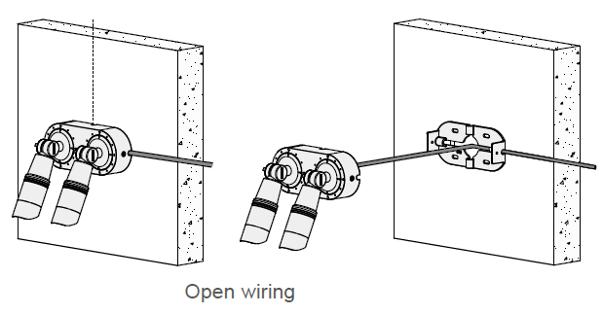

PHOTOMETRIC
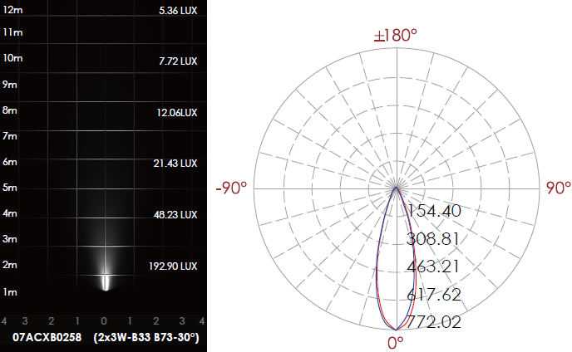

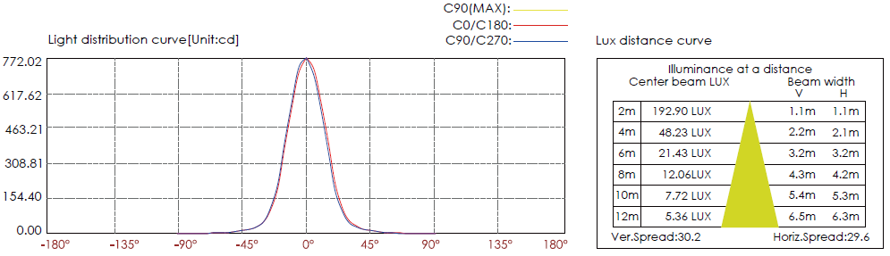

CERTIFICATES




