
Datasheet
No.: 05AGB0126-DC 12 24-B106-24°
Version: 2025-11-05-03
ITEM: 05AGB0126 | INPUT VOLTAGE(V)  DC 12 24 | LENS  B106 | LENS DEGREE(°)θ1/2  24° |  | CCT  3000K
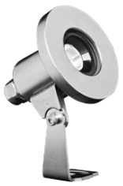  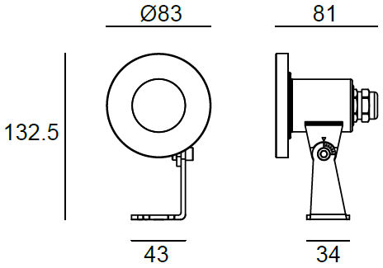 |  | LIGHT SOURCE |  | 1×6W
 |  | CONSUMPTION(W) |  | 7.4
 |  | OPERATING CURRENT(MA) |  | 12=616 24=305
 |  | POWER FACTOR(PF) |  | 1
 |  | LUMINANCE(LM) |  | 520
 |  | COLOR RENDERING INDEX |  | RA: 80
 |  | IK RATING |  | 07
 |  | IP RATING |  | 68
PRODUCT SPECIFICATIONS
FRONT COVER | Hard chromeplated molding shaped stainless steel 316#
HOUSING | Hard chromeplated molding shaped stainless steel 316L#
LIGHT WINDOW | PMMA 8mm
GASKET | Silicone Gasket
CABLE GLAND | IP68 PG-11 copper with nickel-coated
OPERATING RESTRICT | Temperature of water between -20˚ C~40˚ C Less than 2 meter deptht
PCB | Excellent heat conductivity aluminum.coefficient of heat Conductivity≥2.0w/mk
LENS | Optical Lens,efficiency≥85%
LED TYPE | COB
LED DRIVER | Built in on/off driver
POWER CABLE | Outside of luminaire (Without waterstopper)  H07RN-F 2X1.0mm² L=3.0m
DIMMING SUPPORT | External DALl supported TRIAC,0-10V, PWM via external driver on request
WATER PROOF SOLUTION
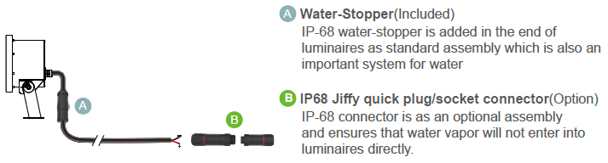

TILTABLE DIRECTIONS
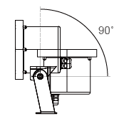

PHOTOMETRIC
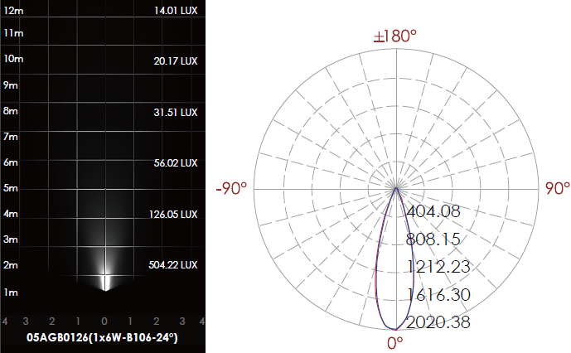

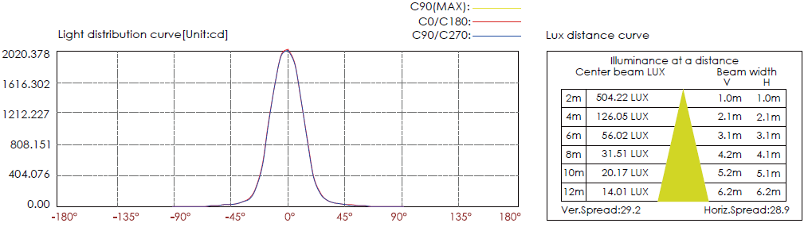

CERTIFICATES




