
Datasheet
No.: 04FBAB2058K-DC 24-FB13B6+FB14B7-20°
Version: 2025-11-05-02
ITEM: 04FBAB2058K | INPUT VOLTAGE(V)  DC 24 | LENS  FB13B6+FB14B7 | LENS DEGREE(°)θ1/2  20° |  | CCT  3000K
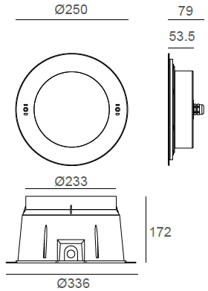  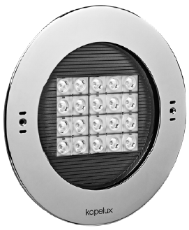 |  | LIGHT SOURCE |  | 20×3W
 |  | CONSUMPTION(W) |  | 73.2
 |  | OPERATING CURRENT(MA) |  | 3050
 |  | POWER FACTOR(PF) |  | 1
 |  | LUMINANCE(LM) |  | 5561
 |  | COLOR RENDERING INDEX |  | RA: 80
 |  | IK RATING |  | 10
 |  | IP RATING |  | 68
PRODUCT SPECIFICATIONS
FRONT COVER& HOUSING | Hard chromeplated molding shaped stainless steel 316L#
LIGHT WINDOW | step tempered glass. T=10mm
CABLE GLAND | IP68 PG-11 copper with nickel-coated
GASKET | Silicone Gasket
SLEEVE | PC/ABS ALLOYS
OPERATING RESTRICT | Temperature of water between -20˚C~40˚C  Less than 2 meter depth
PCB | Excellent heat conductivity aluminum.coefficient of heatConductivity≥2.0w/mk
LED TYPE | SMD
LENS | OPTICS Lens,efficiency≥85%
GLASS PRESSURE CAPACITY | 1,934kgs
LED DRIVER | Built in on/off driver
BUILT-IN OVERHEAT SENSOR SYSTEM | Automatic Shutdown at 75°C
POWER CABLE OPTIONAL | H07RN-F 2×1.0mm2 with water-stopper, L=1m, 3m, 5m
DIMMING SUPPORT | External DALl supported TRIAC,0-10V, PWM via external driver on request

WATER PROOF SOLUTION
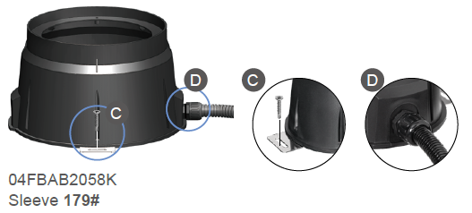
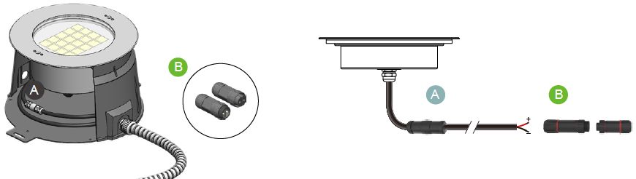
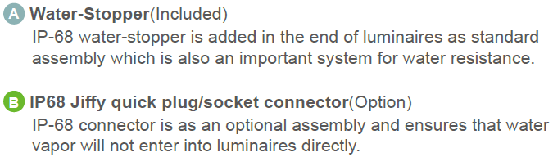
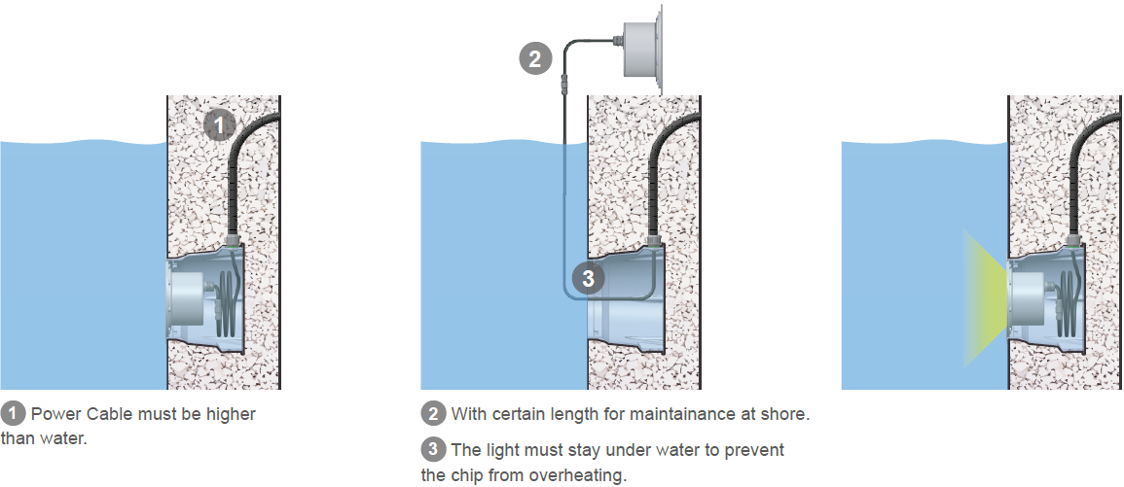
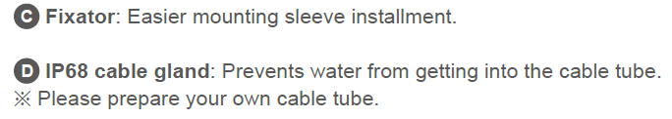

PHOTOMETRIC
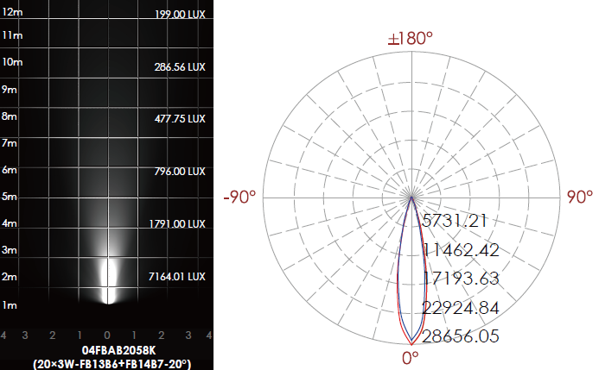

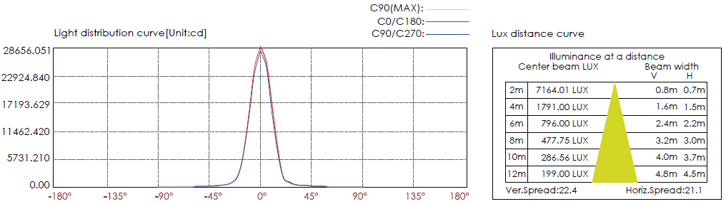

CERTIFICATES


