
Datasheet
No.: 03GKAB1259-DC 24-FB12B5-45°
Version: 2025-10-31-02
ITEM: 03GKAB1259 | INPUT VOLTAGE(V)  DC 24 | LENS  FB12B5 | LENS DEGREE(°)θ1/2  45° |  | CCT  3000K
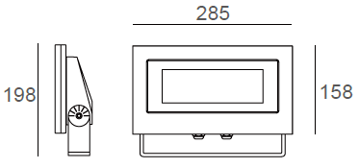  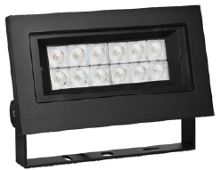 |  | LIGHT SOURCE |  | 12×3W
 |  | CONSUMPTION(W) |  | 35
 |  | OPERATING CURRENT(MA) |  | 1430
 |  | POWER FACTOR(PF) |  | 1
 |  | LUMINANCE(LM) |  | 2940
 |  | COLOR RENDERING INDEX |  | RA: 80
 |  | IK RATING |  | 06
 |  | IP RATING |  | 66
PRODUCT SPECIFICATIONS
HOUSING | 12# Die-casting dark grey powder coated aluminum  T=60-80μm.Adhesion of ISO class 1/ASTM class 4B
LIGHT WINDOW | Tempered Glass.T=3mm
GASKET | Tooling shaped seal
LED TYPE | SMD
LED DRIVER | Built in on/off driver
POWER CABLE | Outside of luminaire (Without waterstopper)  12V/24V: H05RN-F 2×1.0mm², L=2.0m
DIMMING SUPPORT | External DALl supported TRIAC,0-10V,PWM via external driver on request
OPERATING RESTRICT | -20˚C~40˚C
WATER PROOF SOLUTION
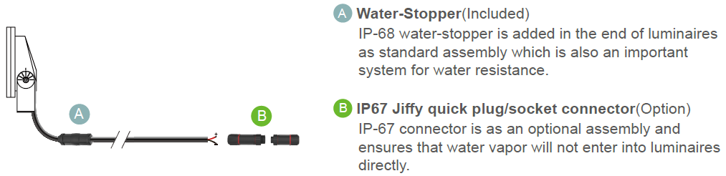

PAINTING COLOR
  Primary   |       Secondary      

PHOTOMETRIC
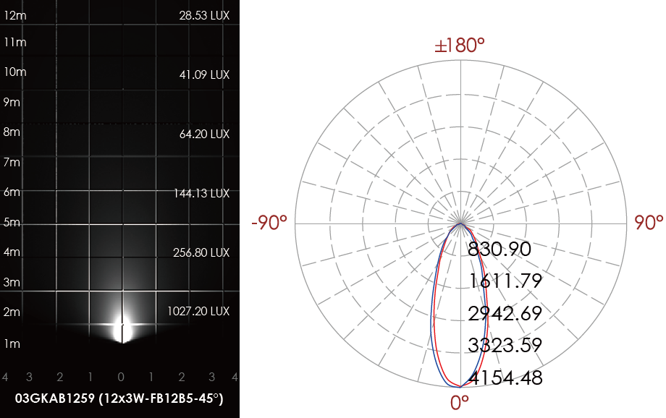

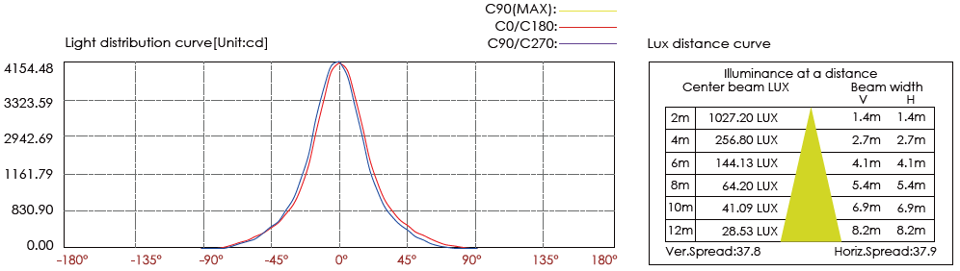

CERTIFICATES




