
Datasheet
No.: 03CQUB1865-120 240-B92-20°
Version: 2025-10-31-02
ITEM: 03CQUB1865 | INPUT VOLTAGE(V)  120 240 | LENS  B92 | LENS DEGREE(°)θ1/2  20° |  | CCT  3000K
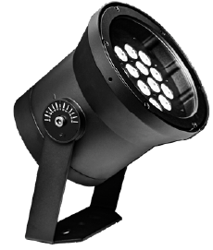  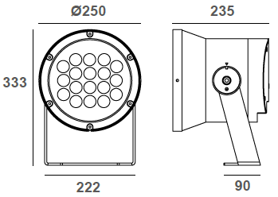 |  | LIGHT SOURCE |  | 18×4.5W
 |  | CONSUMPTION(W) |  | 120=90 240=90
 |  | OPERATING CURRENT(MA) |  | 120=772 240=394
 |  | POWER FACTOR(PF) |  | 1
 |  | LUMINANCE(LM) |  | 7771
 |  | COLOR RENDERING INDEX |  | RA: 80
 |  | IK RATING |  | 07
 |  | IP RATING |  | 66
PRODUCT SPECIFICATIONS
HOUSING | 12# Die-casting aluminum powder coated.  T=60-80μm.Adhesion of ISO class 1/ASTM class 4B
BRACKET | Iron powder coated. T=2.5mm
LIGHT WINDOW | Tempered glass.T=3mm
LED TYPE | SMD
LED DRIVER | Built in on/off driver
CABLE GLAND | IP68 PG-11 PA66
GASKET | Tooling shaped seal
POWER CABLE | Outside of luminaire (Without waterstopper)  120V/240V: H07RN-F 3×1.0mm², L=2.0m
OPERATING TEMPERATURE | -20˚C~40˚C
WATER PROOF SOLUTION
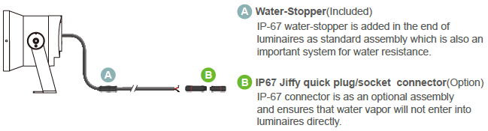

ACCESSORIES(OPTIONAL)
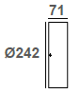  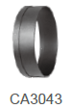  Hood | 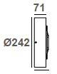  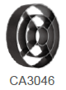  Anti Glare Louver

PAINTING COLOR
Primary     | Secondary        

PHOTOMETRIC
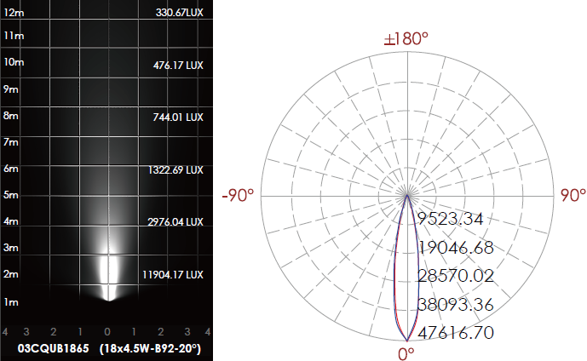

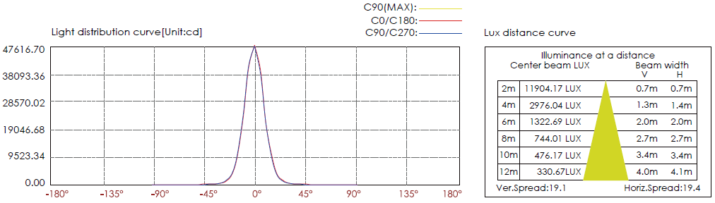

CERTIFICATES





